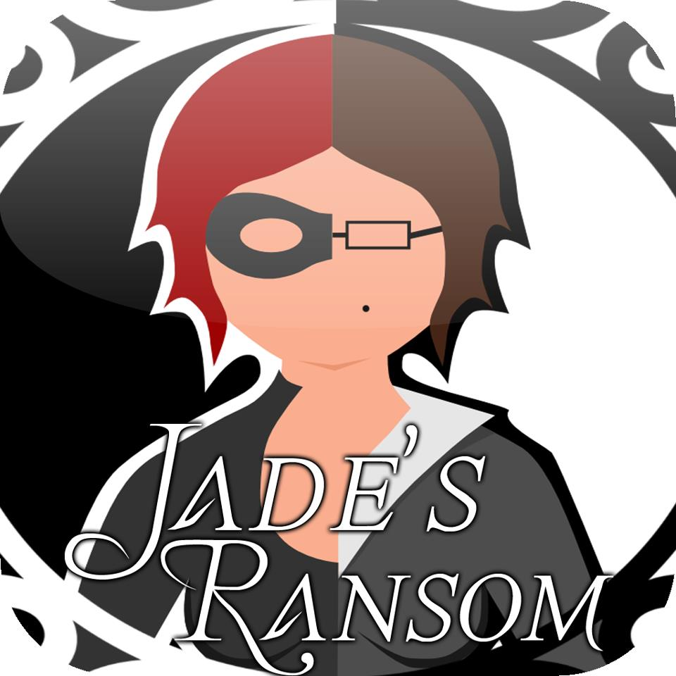
Game Design Document
New Dogs Old Tricks

All content copyrighted to New Dogs Old Tricks (2012) unless referenced otherwise.

Contents
- Game Overview
  - Title
  - Tagline
  - Game Concept
  - Genre
  - Play Modes
  - Target Audience
  - Game Flow
  - Look/Feel
  - Project Scope & Monetisation
  - Influences
  - Copyright
- Gameplay Mechanics
  - Puzzle Structure
  - Objectives
  - Rules
  - Physics
  - Controls
  - Difficulty Settings
  - Scoring
  - Achievements
- Menu Screen
  - GUI Screen & Level Select
  - HUD Screen
  - Pause Screen
  - Level Interim Screens
- Story
  - Back Story
  - Characters & Settings
  - Game World
- Level Synopses
  - House Training Level
  - Mansion
  - Jewellery Store
  - Museum
  - Art Gallery
  - Bank
  - Easter Eggs

- Interface
  - Camera
  - Lighting
  - Rendering
  - Audio & Sound Effects
  - Voice Actors
  - Animations
- A.I.
  - Enemies
  - Collision Detection
  - Pathfinding
- Technology
  - Hardware
  - Software
  - Procedures
  - Game Engine
  - Scripting
- Concept Art
  - Characters
  - Levels
  - Cut Scenes
- Management
  - Personnel
  - Time Frame
  - Bug Testing
  - Player Testing & Feedback
  - Promotional Material
  - Downloadable Content
- Appendices
  - Bibliography
  - Final Character Renders
  - Storyboard
  - Achievement Images

1.0 Game Overview
Title
Jade’s Ransom
Tagline
Desperate times call for desperate measures.
Game Concept
The main concept for the game is to navigate through levels taking as much loot as possible in the allotted time frame. The player controls a female cat burglar who has viable reasons for her actions. She must raise enough money to pay a ransom to have her kidnapped child returned to her from an evil loan shark. The player must use his/her skills to navigate in third person through the levels, solving puzzles and ultimately completing the adventure to reunite the heroine with her son. Jade’s Ransom is a clever game that will make the player think and strategize by taking away the all-guns-blazing approach to modern action-adventure titles, with timing and strategy key to completing the levels.
Genre
The game fits into the stealth, action-adventure and puzzle game genres.
Play Modes
The game will feature single player action only, with no multiplayer options.
Target Audience
The target audience for the game ranges from teenagers through to gamers in the mid-30 age range, who own smartphones and are regular users of the app stores for Android and iOS. The game will receive a PEGI 7 rating due to the nature of kidnapping and ransom as main features of the story.
Game Flow
The player has different difficulty settings for each level, with each option depending on the number of loot collectables available and differing security features to think about for each. Cover will be provided to hide from guards, who will patrol certain areas, but each level difficulty is a new experience and will force the player to change their routes in order to collect the maximum loot available.

Look & Feel
The design style will take inspiration from Pixar for a brighter colour set than in realistic games, with the character proportions and styles similar to Team Fortress and inspiration from early Tomb Raider games for promoting a female heroine who is determined, strong willed and independent. Metal Gear Solid is an inspiration for the stealth elements of the level design and security features throughout the levels.
Project Scope & Monetisation
The project has been designed primarily to be played on Android and can be converted to be played on iPad and iPhone systems as well as online on the game’s own website. Downloadable content could be produced for purchasable additional levels and storyline arcs if the game becomes a hit with download numbers on the initial free game. The story has finished open ended allowing for this option to be implemented. Third party advertising could be implemented to fill part of the loading screens and menu screens.
Influences
Jade’s Ransom has taken inspiration from various areas in games and films. These include:
Metal Gear Solid Series – Crouch Walk, Security Features & Stealth Game Play
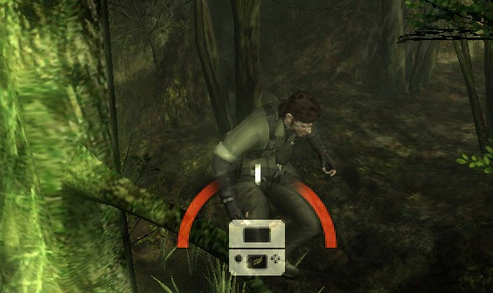
Penelope – Camera Angle
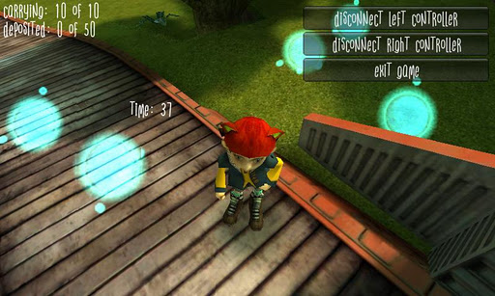
Angry Bots – Style, Lighting & Game Play Mechanics
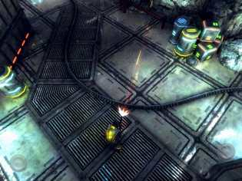
Tomb Raider – Female Character
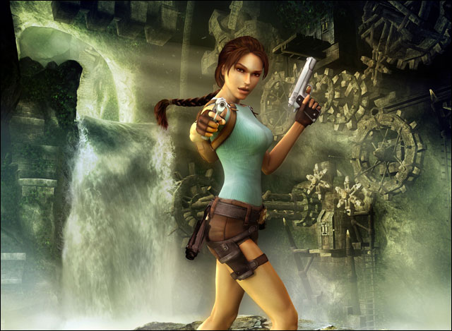
Thief – Female Character & Game Play
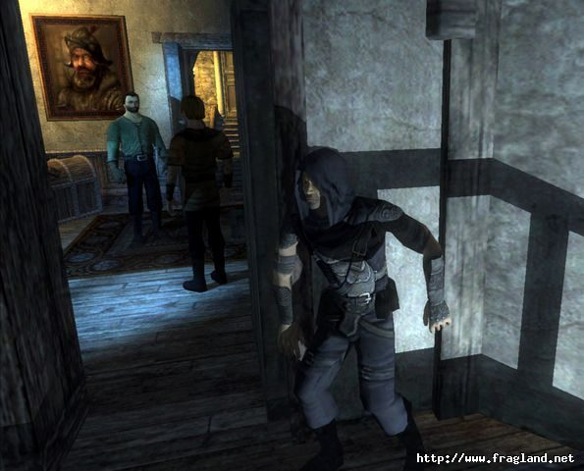

Perfect Dark – Female Character Style
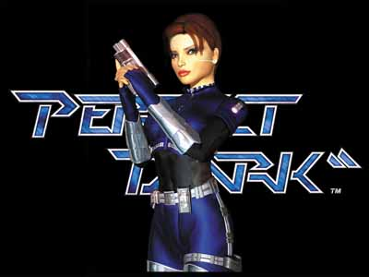
Pixar – Proportions, Art Style & Lighting
Copyright
The game uses fresh ideas, original concepts and original assets to avoid copyright infringements and provide a new style of app download for smartphone customers. All inspiration for designs can be seen in the above section. All content is copyrighted to New Dogs Old Tricks (2012).

2.0 Gameplay Mechanics
Puzzle Structure
The puzzles will be simple in style but complex in execution, with combinations on the various levels. These will include mazes, hidden paths in the floor, avoiding multiple enemies such as a guard and security camera’s movements and path finding mini-games simulating hacking to open doors and safes. These puzzle elements will require the player to think about their actions and strategize within the levels, planning where to go to find a safe route. These routes will be increasing in difficulty with the levels difficulty options, differing to force the player to change their tactics. The mini games implemented into the game will involve dragging a key to a lock while avoiding obstacles on the screen, simulating hacking device Jade uses to open safes and unlock doors. We have called these mini games the Hacktron. An example can be seen below:
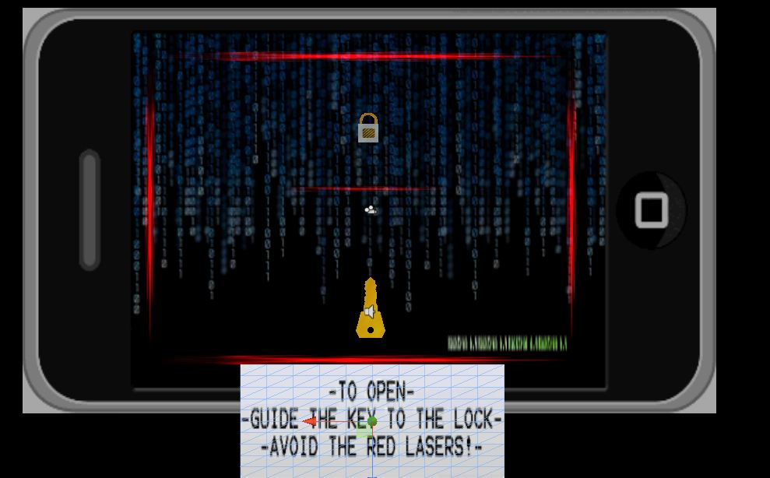

Objectives
The overall main game objective is to steal as many items without getting caught by the security features implemented into the levels, unlocking new levels as the collected loot increases. The main story objective is to complete each level in order to amass a ransom to exchange for Jade’s son by the antagonist Big Vince at the end of the game.

Rules
The game rules include:
- Three chances at stealing the loot of a level, equivalent of losing a “life” when you get caught by a security feature.
- Each level and difficulty has a time limit to steal the loot otherwise Jade is considered caught and the level is uncompleted.
- The more loot you collect over through the levels builds up an overall number, which is used to increase the levels available to play.
- For each level Jade must reach the end marker to complete the level.
Physics
The game is in a real world setting, so gravity will be in effect as well as collision detection between the main character and other objects in the levels i.e. the loot and enemy security guards/security features. If Jade enters the field of view of a security guard or security feature sensor, she is reverted to the start of the level and loses a game life. Loot can only be collected by tapping the loot item on the screen, but Jade must be next to the loot to do this as you need to be next to something in real life to pick it up.
Controls
The game will be using touch screen controls, with an on-screen joystick and crouch button. Clicking on the crouch button will move the character into crouch mode, or back into a normal walk if already crouched, for movement around the map. For collecting loot and pressing buttons/end markers the player must press the specific item on the screen.
Difficulty Settings
There will be a training level and initial level with one difficulty then four subsequent levels each with an easy, medium and hard setting. The map for the easy setting will include less loot, an increased time limit and less security than medium, and again from medium to hard difficulty the time decreases and loot increases. The same map will be used for each level, but sections will be different in terms of security to prevent the player accessing loot areas easily in higher difficulty settings

Scoring System
The end score for the player will be deduced on the amount of loot collected in between the player moving from the beginning of the level to the end. The reward will be the number of loot items collected added to the overall total, which is used to unlock levels further in the storyline. There are unlock-able achievements implemented to add varying challenges to the game and add replay ability. The scoring structure for the levels will be as follows:
Jade’s Ransom Level Scoring Structure:
Overview
House Tutorial
Mansion (Unlock: complete House)
Jewellery Store (Unlock: complete Mansion)
Art Gallery (Unlock: score level from Jewellery)
Museum (Unlock: score level from Art Gallery)
Bank (Stage 1, Stage 2, Stage 3) (Unlock: score from Art Gallery & Stage Completions)
House
Single tutorial difficulty to begin the story and unlock the Mansion level
No Time Limit
Mansion
Single level difficulty to find blueprints
Guard dog patrolling in back garden on way out
Time Limit – 180 seconds.
Jewellery Store
Loot:
Cash Register
Diamond
Vault Safe
Shop Floor Shelves x7
Security:
Cameras x2
Moving Lasers
Scoring:
Easy: -/3 (Lasers)
Medium: -/7 (Lasers, 1 Camera)
Hard: -/10 (Lasers, 2 Cameras)
Time Limits:
Easy: 120
Medium: 170
Hard: 180
Loot to collect for next level unlock: 10/20
Museum
Loot:
Cash Register x2
Space Ship Contents
Sarcophagus
Fossils x3
Money in Vending Machine
Gold Artefacts x2
Security:
Guard x2
Solar System Spinning
Scoring:
Easy: -/3 (Solar System, Sleeping Guard)
Medium: -/7 (Solar System, Sleeping Guard)
Hard: -/10 (Solar System, Sleeping Guard, Patrolling Guard)
Time Limits:
Easy: 200
Medium: 240
Hard: 270
Loot to collect for next level unlock: 15/20
Art Gallery
Loot:
Faberge Egg
Painting x6
Wallet
Safe Contents
Money from Vending Machine
Security:
Lasers
Guard Dog
Sleeping Guard
Alarmed Flooring
Scoring:
Easy: -/3 (Floor, Sleeping Guard)
Medium: -/7 (Floor, Guard Dog, Sleeping Guard)
Hard: -/10 (Floor, Guard Dog, Sleeping Guard, Lasers)
Time Limits:
Easy: 145
Medium: 185
Hard: 230
Loot to collect for next level unlock: 12/20
Bank
Stage 1
Loot:
Account Books in Office Desk x3
Account Books on Tables x2
Security:
Camera x2
Scoring:
-/5
Time Limit: 180

Stage 2
Loot:
Manager’s Office
Loot in Cubicles x5
Filing Cabinet
Security:
Guard
Cameras x3
Scoring:
-/7
Time Limit: 180
Stage 3
Loot:
Wallet
Locker Contents
Deposit Boxes x2
Final Item
Security:
Guard
Lasers
Moving Laser
Tripwire Floor
Scoring:
-/5
Time Limit: 200

Achievements
The following achievements will be unlockable whilst playing through the levels of Jade’s Ransom:
- Woman On A Mission – Pick up the ransom letter to start your pursuit.
- Not Safe Any More – Crack the safe.
- Scrambled or Over Easy? – Steal the Faberge egg.
- Diamonds Are A Girl’s Best Friend – Complete the Jewellery Store level.
- Feeling Creative – Complete the Art Gallery level.
- Nostalgic – Complete the Museum level.
- Houston, We Have A Problem – Steal from the space craft.
- Easy When You Know How – Find the map for the Art Gallery floor.
- Big Withdrawal – Complete all 3 Bank stages.
- Master Thief – Steal every item in the game.
- Where’s My Mummy? – Open the sarcophagus.
- Sneaky – Complete a level without being caught by security.
- Inception – Find the item breaking the fourth wall.
- Got To Start Somewhere – Steal your first item.
These achievements will be shown in an option from the main GUI menu, with padlock images shown before the item is unlocked and an image is changed to reflect the player success. Achievements will be kept secret with no description unless unlocked. The images can be seen in the appendices. The first two achievements, Woman On A Mission and Not Safe Any More, are implemented into the game while the others are planned to be added in the near future.

3.0 Menu Screens
GUI Menu & Level Select
The GUI menu will be feature the following accessible buttons:
- Play Game
- How To Play
- Achievements
- Credits
- Quit
The menu screen is 3D, set in Jade’s house from the tutorial level, and upon pressing a function button the camera will pan to another section of the room to reveal the relevant screen. Upon accessing the “Play Game” button a second scene will open showing the individual buildings the levels are set in on a 2D map on the wall, with each building having an icon identifying the selection option. When selecting a level building a difficulty menu will open up with options for an easy, medium or hard play through before the level is open to play. These select screens will be blueprints of the building with hints for the player as to loot locations and security. The buildings available for selection will be:
- House (tutorial)
- Mansion
- Jewellery Store
- Museum
- Art Gallery
- Bank – 3 separate stages available to scroll through as opposed to the Easy, Medium and Hard format. Lobby, Office and Vault will be unlocked as you the player plays through the respective previous levels.
The “How To Play” button will show an example of a level in play, with highlighted areas describing the character control functions and on screen HUD displays, preparing the player for playing the game and preventing any confusion. The tutorial level also allows the player to become comfortable with the controls before being placed in a time limit and dangerous environment.
The “Achievements” option will pan to the table and an open book, with each page a different achievement. The images will be padlocked if the achievement is yet to be unlocked but the description will be underneath the picture when the achievement is unlocked by the player.
The credits will pan the camera to portraits on the wall, naming the members of the production team and their lead roles within the project and including clickable links to their personal portfolio websites. The “Quit” feature will return the player to their main phone screen menu and close the application.
HUD Menu
The HUD display will include the “Home” button in the top right corner which quits the level and returns the player to the main menu, the timer counting down to zero on the left at the top and the number of lives for the player above the timer. A joystick in the bottom left corner will control the character movement, with the crouch button in the bottom right. When standing next to the loot or an accessible button the icon will be on screen and the item will be clickable within the game area of the screen. The number of loot will show on the screen when an item is collected, next to the home button in the top right corner of the screen. Upon nearing an item of interest a question mark will pop up above Jade’s head, showing the player they are near loot or a switch. This is an example of the HUD design:
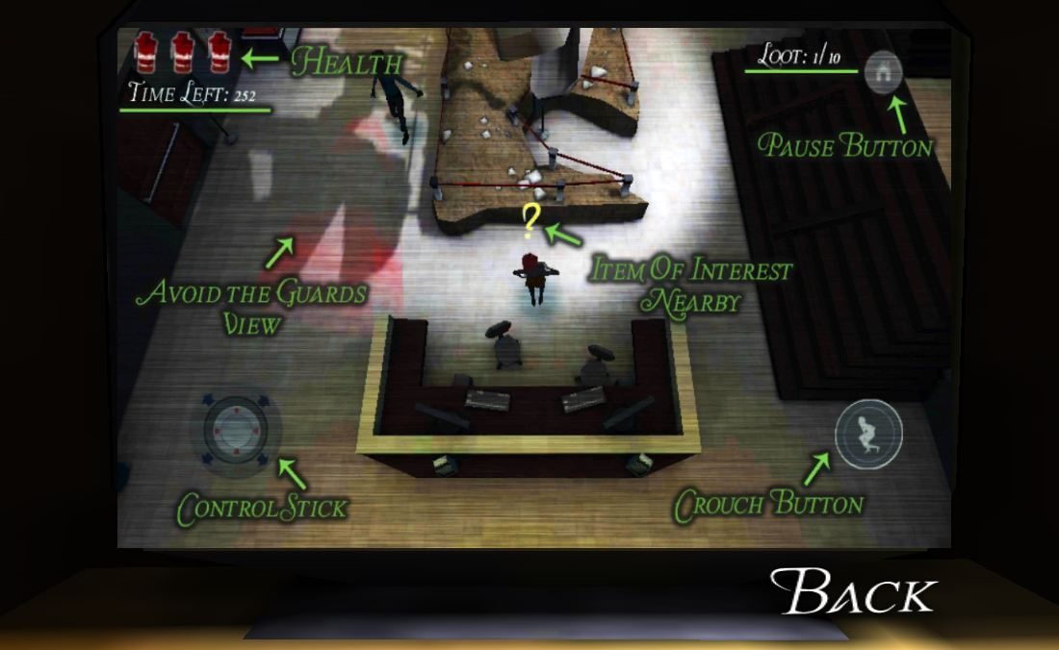
Pause Menu
Upon accessing the “Home” button the game is effectively paused while the player can either choose to quit the level or press “Home” again to carry on playing. The timer for the level does not carry on counting down while the “Home” button is active.
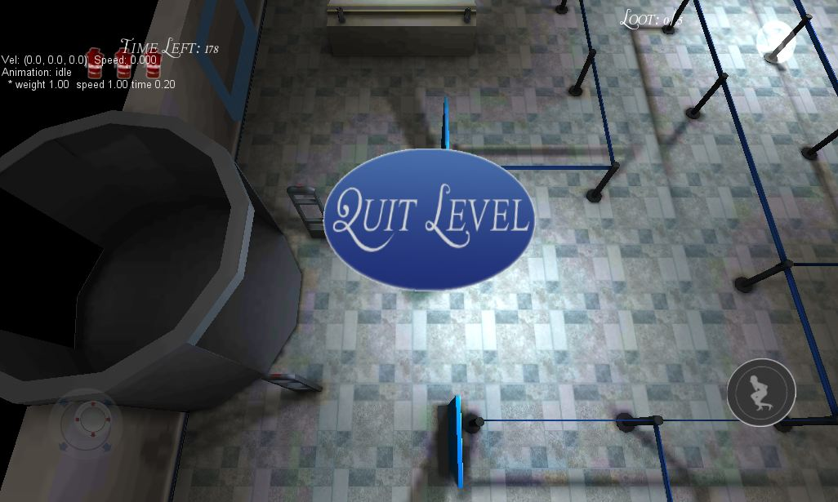
Level Interim Screens
Upon completing a level the player is reverted to the level select screen, which show the score statistics for the level and its’ relevant difficulty settings. If the player fails a level then a commiserations screen will be shown with a continue option at the bottom returning the player to the main menu screen.
Level Commiseration Screen:
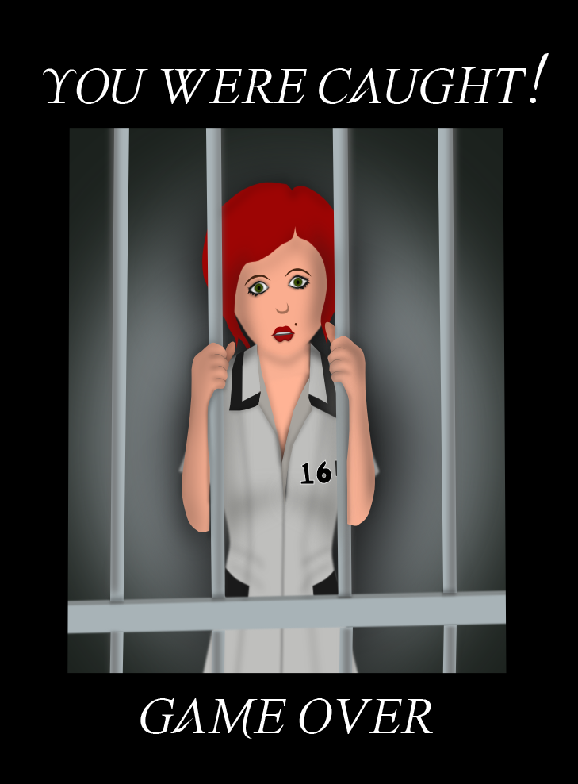
Game Completion Screen

4.0 Story
Back Story
After losing her partner, Jade Stone found it difficult to make ends meet looking after her young son Tommy, working in the modern economic climate and managing debts to notorious loan shark Big Vince left by her late husband Steve. After banks turned her down for a loan and unable to afford the loan repayments, Jade returned home one day to find her house ransacked and her son gone. She uncovers a ransom letter from Big Vince with his demands; if she wants to see her son again she needs to find the money somehow. Jade has to turn to a life of crime to raise the ransom money, for the sake of her son. How far would you go to save your family?
Characters
The game will feature a main antagonist, Big Vince, and protagonist Jade Stone. Jade’s son Tommy and late husband Steve are also mentioned in the storyboards but not seen within the game play. Two un-named security guards and a guard dog also feature within the game levels protecting the various establishments Jade is forced to steal loot from.
Jade Stone
Age: 30
Occupation: Receptionist
Eye Colour: Green
Hair Colour: Brown/Red
Bio: Jade is a young widow who lost her partner to suicide 2 years ago. She works long hours as a receptionist for a local successful businessman while raising her 6 year old son Tommy Stone. A high-school gymnastics champion, Jade graduated from university while also working part-time for her husband Steve’s struggling electricians business. After Steve passed away Jade was left with the debts her husband and struggled to get a full time job due to looking after new born Tommy.
Big Vince
Real Name: Vincent Kennedy
Age: 52
Occupation: Loan Shark/Criminal
Eye Colour: Blue
Hair Colour: None
Bio: Little is known about the mysterious criminal, only rumours.
Tommy Stone
Age: 6
Occupation: None
Eye Colour: Blue
Hair Colour: Blonde
Bio: Young Tommy is Jade’s only child, who is ruthlessly taken from her by loan shark and criminal Big Vince.
Setting
The game is set in a modern day fictional town of Asha Town, with British characters.
Game World
The playable elements of the game world include Jade’s house as the tutorial level, the mansion home of Jade’s boss, a jewellery store, museum, art gallery and major bank within the town. A town map is the setting for the GUI level select page, with the playable areas of the city accessible as GUI buttons.
5.0 Level Synopses
Each level within the game will have 3 difficulty settings, easy, medium and hard. These setting will effectively open 3 separate levels, as the harder the difficulty setting the more loot is available therefore more security protecting the loot. Each level has a time limit to get from the beginning to the end, with the limit changing with the difficulty to increase the challenge for the player. The only exceptions to this are the House tutorial and Mansion levels which only include one difficulty, while the Bank level is split into Lobby, Office and Vault sections because it is the game finale level.
Training Level: House
The ransacked house training level will introduce the player to the game controls. Starting in the kitchen, the player will manoeuvre around the fallen chairs and table to a partially blocked door to the living room. A hint message explaining the loot collect will pop up on nearing the table, while the crouch and crouch walk moves hint will appear telling the player how to crawl under the blocked door. Once in the living room a broken lamp will provide the danger due to its electric change, and a message will alert the player to danger objects within the game levels. This is to show the player how to avoid losing a “life” by entering the field of vision of enemies or enemy surveillance equipment. After navigating past the lamp to the end of the living room the player will find the ransom note, which will have to be collected by tapping the screen when a question mark icon becomes visible while standing next to the collectable item.
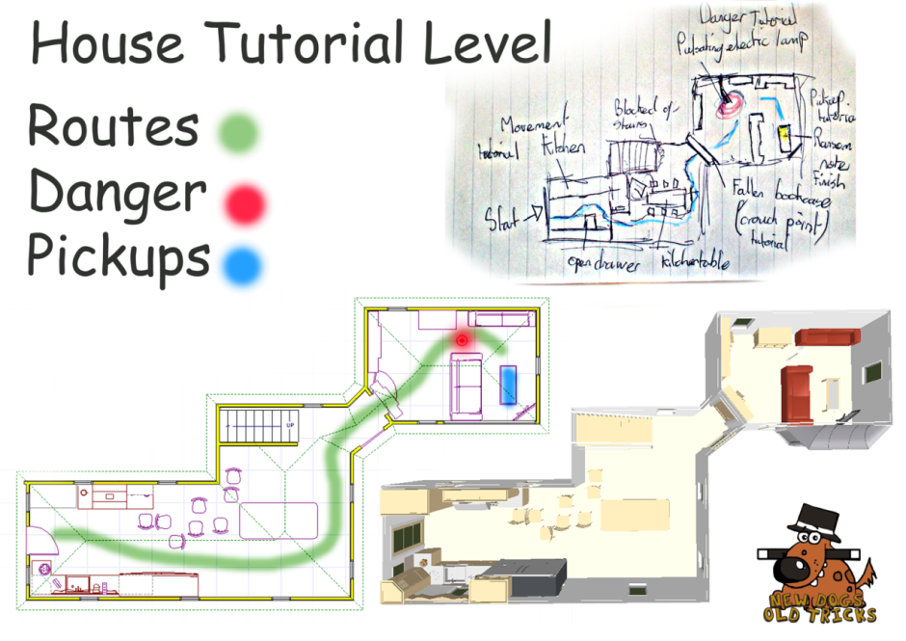
Level Rules:
- You must avoid the electric field of the broken lamp.
- You must collect the ransom note to complete the level.
Level 1: Mansion
This level was added at a later stage and was initially not in the game’s plans, but was added to increase the story element and explain why Jade has blueprints for the city’s buildings. The main aim of the mansion is to find these blueprints hidden within the level. The inclusion of this level explains how Jade can access buildings and plan to loot their contents. The house is of Jade’s businessman boss, linking into the story how she is able to know the blueprints’ location in the first place. The level forces the player to explore and use common sense in finding the place where the blueprints are hidden before escaping unnoticed from the mansion. The blueprints are in a safe which must be opened using the Hacktron mini game puzzle.
Level Rules:
- The player must find the blueprints in the specific time limit.
- You must complete the Hacktron puzzle to access the blueprints.
- The blueprints location is unknown and unspecified.
- The player must avoid the guard dog’s field of vision/not get too close when walking behind.
- You must collect the blueprints and reach the garden gate to finish the level.

Level 2: Jewellery Store
The first main game level unlocked is the Jewellery Store, with the easy difficulty choice seeing the player limited to collecting 3 loot items: the diamond, cash register and safe contents. The only security features are the moving laser sensors protecting the way to and from the diamond. A switch must be pressed in the back room to unlock the safe room. The safe must be opened by completing a Hacktron puzzle.
The second difficulty level includes all the features of the first level, with 5 loot items available in some of the display cases in the main room. A security camera is also added protecting the door to the safe room.
The hard difficulty setting combines the first two difficulties but with 10 loot items in total, with the extra loot also added to the banks of display cases. An additional security camera has been added protecting the door to the laser sensor room, making it tougher for the player to reach all the display cases and navigate back from opening the safe room and collecting the diamond.
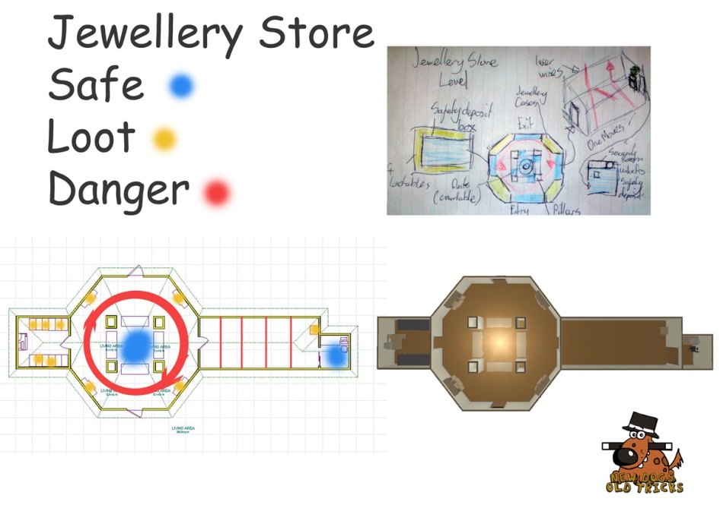
Level Rules:
- You must avoid the camera (s) field of view in the centre chamber on Medium and Hard difficulties.
- You must avoid the moving laser sensors on all difficulties.
- You must press the button in the security room to allow the deposit box area to become accessible.
- You must complete a Hacktron puzzle on the safe to unlock the contents.
- You must reach the exit door in the centre chamber to complete the level.

Level 3: Museum
The museum main room will have a centrepiece dinosaur skeleton, with a cash desk in front of the player at the beginning of the level. The player must complete a Hacktron puzzle to unlock the door to the space room on the left hand side. Inside this room is a spinning planetarium that eliminates the play if they collide with a planet or its support beams. Three wall panels can be accessed to open the space ship and collect the loot inside and move back into the main room. On the hard difficulty setting a guard will be walking around the centrepiece.
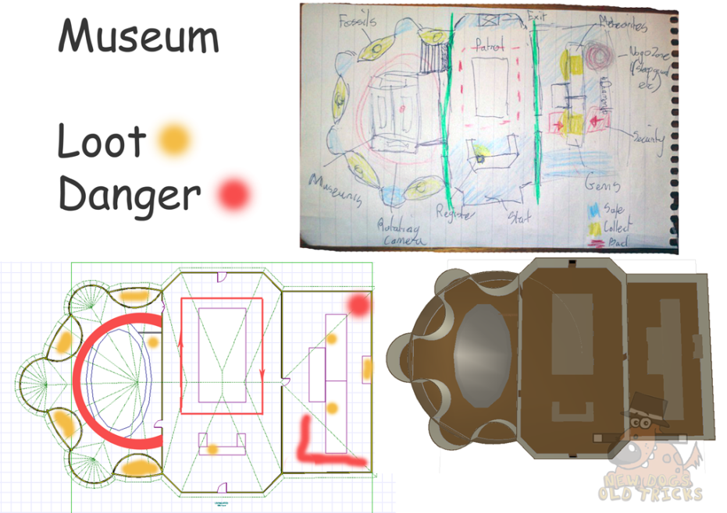
The right side of the room contains an Aztec theme, with gold pyramids and artefacts. A button at the bottom section of the room opens a sarcophagus, with gold inside. This is only open for a limited amount of time, and the player must then move around the exhibits to collect the loot in the time limit. The easiest way is blocked by a sleeping guard with a proximity sensor, so the player is forced to move round the long way. On the easy setting the loot is limited to these 2 main pieces and a fossil in the main room, with further gold pieces and fossils available in the ascending difficulties.
Level Rules:
- You must avoid the guard’s field of view in the direction he is facing.
- You must avoid the immediate proximity of the sleeping guard, otherwise he will wake up and you will be caught.
- To complete the level you must reach the door at the opposite end of the middle room, where you begin.
- You must complete the Hacktron puzzle to unlock the space room.
- You must not collide with any section of the planetarium.
- You must collect the loot from the sarcophagus only when it is opened using the switch.
Level 4: Art Gallery
The Art Gallery consists of a main corridor room with paintings lining the walls, a room containing several art pieces on plinths surrounded by a pressure pad floor and a room containing mostly boxes in a yet-to-be opened room. The crate room has paintings which can be looted, but with a guard dog patrolling on the medium and hard difficulties. At the end of the crate room is the guard’s room with a safe with a Hacktron puzzle protecting the contents, a map of the safe route to the Faberge egg and some items to loot in the harder difficulty settings. On “Easy” the only security is the sleeping guard and pressure floor surrounding the Faberge egg, with “Medium” including the guard dog in the crate room and “Hard” adding static lasers in the main corridor for a further challenge.
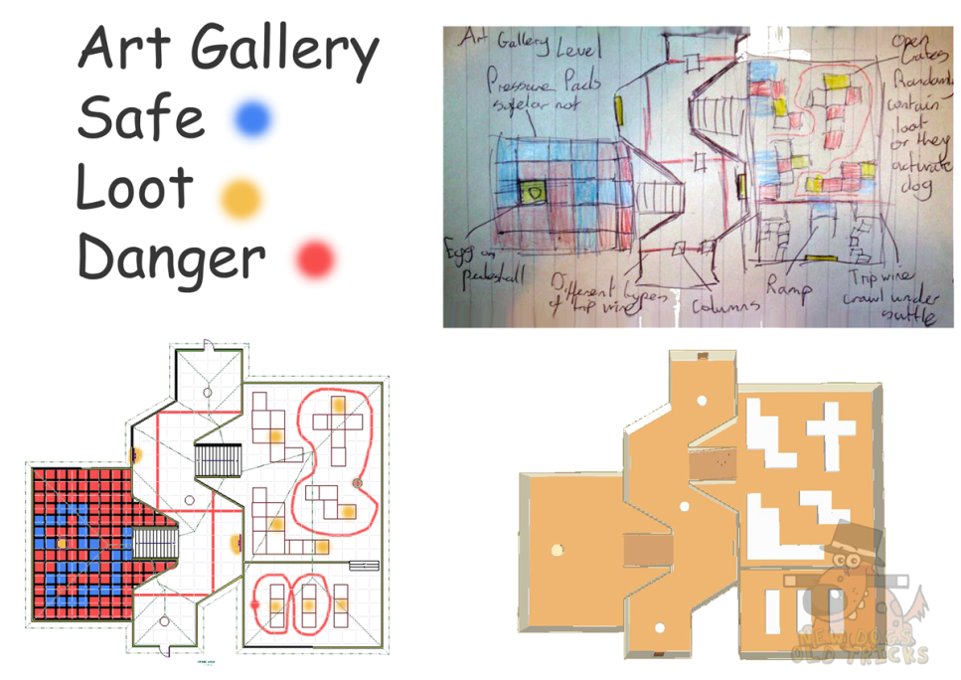

Level Rules:
- You must avoid the laser sensors while collecting the loot in the main corridor on the hard difficulty setting.
- You must avoid the field of view of the guard dog.
- You must avoid the sleeping guard; otherwise waking him will result in losing a “life”.
- You can only step on the safe pathway to avoid the floor sensors of the Faberge egg room.
- You must complete the level by reaching the door at the end of the main corridor.
- You must complete a Hacktron puzzle to open the safe to collect the loot inside.

Level 5: Bank
Stage 1: Lobby
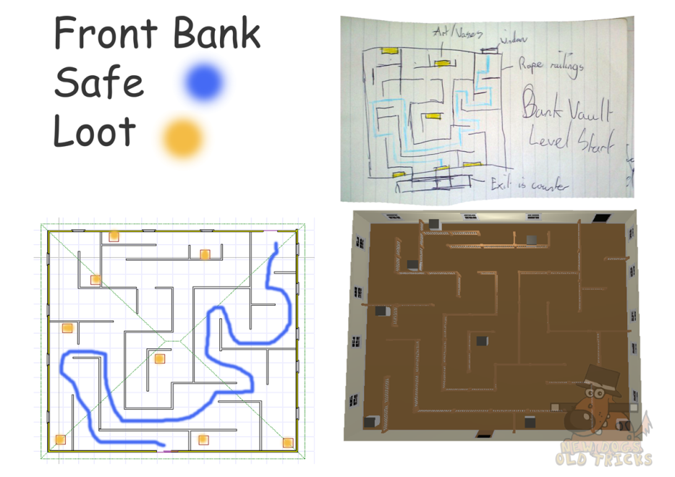
The bank level will be split into three stages rather than easy, medium and hard settings, as it is the grand finale level of the game. The first stage will be the main lobby and waiting area, with a roped off area creating a maze to reach the main desk, which leads to behind the scenes of the bank. The final level was slightly modified than the above designs, including more of the private desks area and behind the scenes to the lobby. After completing the maze (avoiding the camera panning across) the player will be in the private office area where loot is available behind the desks. There is another camera to avoid while moving behind the main desks, with another piece of loot before finishing the level.
Level Rules:
- You must complete the Lobby to unlock the Office.
- You must stay within the maze area and are unable to cut across any rope barriers.

Stage 2: Office
The second stage of the bank is the behind-the-scenes room featuring desks and bank files. The stage starts after Jade makes it through the bank lobby. The room has walls lined with bookcases full of files, 6 L-shaped desks in the centre of the room along with three support pillars. Each pillar has a camera with a 180 degree rotational view and a security guard will walk around the room in a square along the outer walls. The player must navigate through the desks collecting briefcase full of loot, avoiding the cameras and guard by hiding under the desks to reach the stairs downstairs to the main vault.
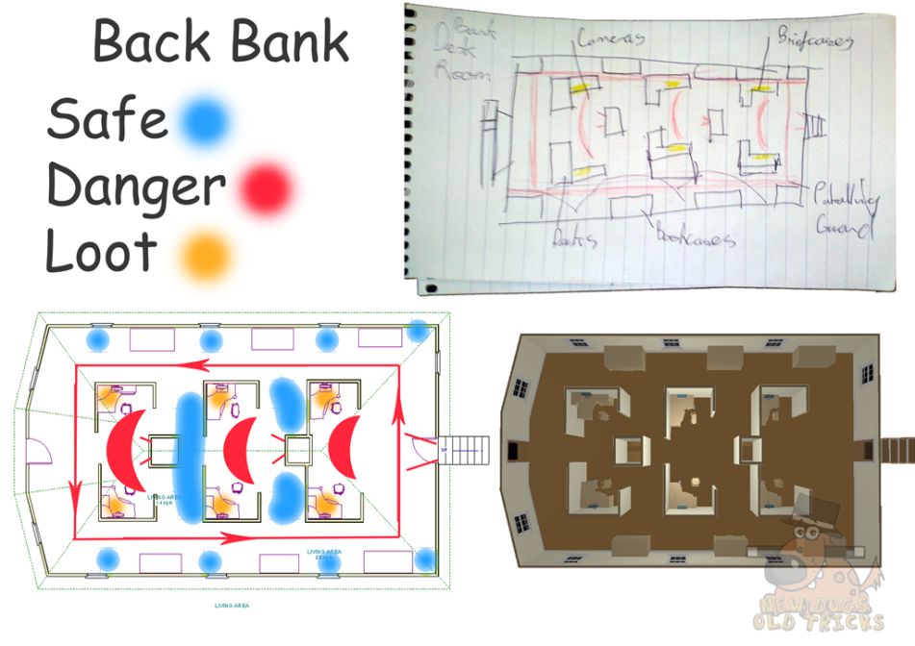
Level Rules:
- You must avoid the cameras’ field of view.
- You must avoid the guard’s field of view as he walks around the level.
- You must reach the staircase to move onto Stage 3.
Stage 3: Vault
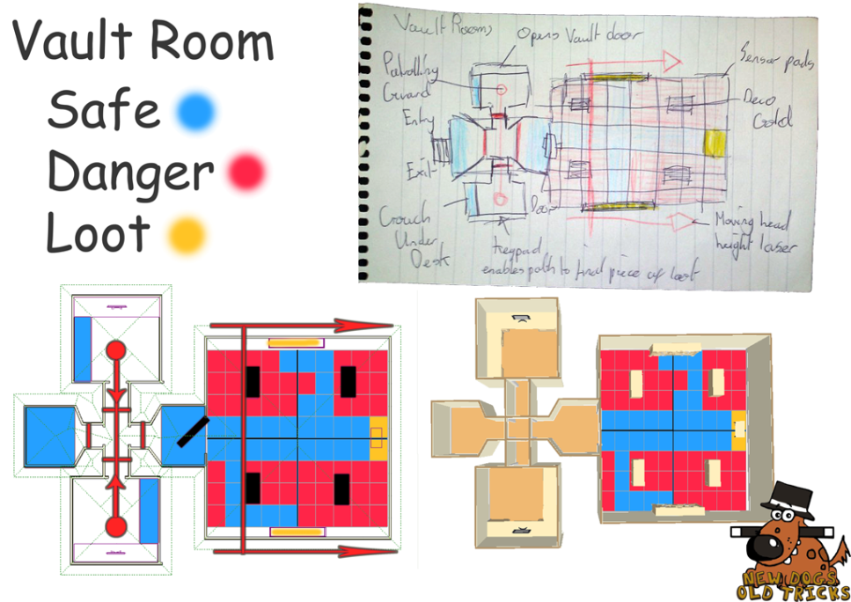
The final stage of the bank level begins at the foot of the stairs at the end of stage 2. The player is faced with a locked vault door in front of them, with a room to the left and right. The room to the left contains a guard room with a screen to see the safe path through the vault room pressure pad floor, while the room to the right contains a switch to open the vault door. A guard patrols up and down between the two rooms, which the player can hide under a desk in either room or hide out of the guard’s line of sight next to the vault door or stairs to avoid detection. On the entrances to both rooms, the foot of the stairs and before the vault are laser sensors to add extra difficulty to the level. Once inside the vault the player has a linear path to follow to collect loot, but certain areas of the floor lead safely to deposit boxes on the walls. A laser also moves horizontally at midriff height lengthways and back, so the player must dodge the laser as well as collecting loot and making sure they reach start of the level to escape from the bank.
Level Rules:
- The player must avoid the laser sensors when entering the security rooms and stairwell.
- The player must avoid the guard’s field of view while moving between the stairwell and vault door.
- You must press the switch to open the vault door before the vault section is available.
- You must only step on the safe floor path and avoid the floor pressure pads within the vault.
- To complete the level and the game you must finish where you started at the stairwell.
Easter Eggs
There are a couple of hidden Easter Eggs within the game. The bank office level contains a computer with a screenshot of the game being made in 3D Studio Max, breaking the 4th wall, while the pictures on the manager’s desk are of the production team.

6.0 Interface
Cameras
The game camera will be third person camera set at a 45 degree angle from a top down view, looking down onto the main character while showing a section of the level both in front and to the sides of the character’s position. This camera angle has been chosen to show the area immediately around the character so it is easier to see accessible items such as loot and press-able buttons. The 3D environment allows depth to be added to the levels. Upon accessing certain points of interest, such as switches opening doors, a short animation plays to alert the player to the action they have just completed.
Main Camera View:
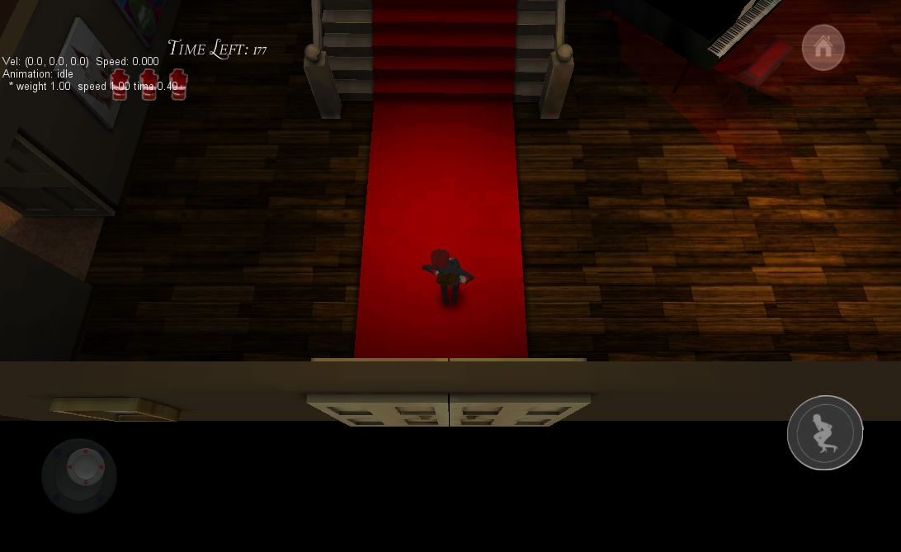
Lighting
Real time lighting will be kept to a minimum as it is extremely processer intensive. As our game will be deployed on many varying mobile devices our options become limited. As a workaround we are using a couple of techniques to fake real time lighting. The main technique will be painting in lighting on our texture maps to give the illusion of directional lighting. Another technique will be light mapping. This feature comes built in with Unity Pro and uses a second UV set to paint shadows and ambient occlusion. The final technique will be static meshes with opacity maps to fake things such as red light beams for laser sensors. All this will save on processing power and enable the game to run smoothly on mobile devices while still adding lighting effects to the scenes.
Rendering
The main game will be forward rendered in Unity Pro using OpenGL with no minimum API. Sub-rendering will be done for high resolution models within 3D Studio Max using the V-Ray renderer. These will be for pictures that will be used as textures in-game and for promotional material.
Audio & Sound Effects
There will be several pieces of audio music and sound effects within the game. These will either be sourced by the team members or composed by a third party source to create a more personal and unique sound for the game. Sounds to be included in the game comprise of:
- Main menu background music.
- Storyboard music and voice acting.
- Level in-play background music.
- Loot collection chime.
- Security camera movement.
- Alarm ringing when Jade is caught.
- Footsteps.
- Dog sniffing.
- Dog barking/alert.
- Laser humming sound.
- Door opening.
- Button press.
All sounds were composed by Matthew Sim, who is credited within the game for his work on the project, aside from some royalty free audio for the character loot collect sound and for one of the level background music.
Voice Actors
Alongside the music and audio effects, voice actors will be used for the characters for in the storyboard. Voice actors will be from New Dogs Old Tricks and used for the following:
Jade Stone – royalty free crying SFX
Big Vince – Christian Harris
Tommy Stone – Matthew Burnill
Steve Stone – Richard Ullah
Most of the story direction and spoken words will be shown via the storyboard cut scene and through the character animations within the game levels to show visually expressed moods and actions, such as surprise when the Jade is caught by a guard.

Animations
The character animations to be used within the game include the following:
- Jade Stone walk.
- Jade Stone crouch/walk.
- Jade Stone idle.
- Jade Stone caught.
- Security Guard 1 walk.
- Security Guard 2 walk.
- Security Guard 1 sleeping.
- Security Guard 1 catches Jade.
- Security Guard 2 catches Jade.
- Guard Dog walk.
- Guard Dog alert/dog sees Jade.
These animations will be made to fit the body shapes of the characters, which will be exaggerated forms of realistic human and dog characters in order to ensure the actions are clearly visible on a phone screen, especially when Jade Stone is caught by a guard or guard dog. When this occurs the animations will be overly exaggerated to emphasise the player losing one of the three chances of completing the level. Motion Capture technology will be used for the animations with additional editing in 3D Studio Max to alter the character rigs.
7.0 A. I.
Enemies
The following enemies and enemy surveillance will be included in the game:
- Security Guard move set 1: the guard has a cone of view and will follow a path. If the player steps in the cone of view a life is lost.
- Security Guard move set 2: the guard is asleep on a chair, with a proximity sensor that wakens the guard if the player steps too close, losing a life.
- Security Guard move set 3: the guard is sleeping lying down on a sofa, with the proximity waking the guard if Jade walks too close. The guard will sit up upon activating the proximity.
- Guard Dog: the dog follows a path and has a cone of view the same as the security guard, with a life lost if the player enters the field of view.
- Camera: the camera field of view rotates 180 degrees, with a life lost if the player enters the field of view.
- Laser Sensor: the lasers move horizontally or stay at a static midriff height, and require crawling under. If the player collides with a laser they lose a life.
- Pressure Pad Floor: The safe floor path is surrounded by squares with collision detection to simulate pressure sensors that will lose a life for the player if they deviate from the safe path.
Collision Detection
Collision detection will be made using simple colliders. This will be attached to the enemies and highlighted with a red glow so the player can clearly see dangerous areas to avoid.
Path Finding
Pathfinding will be simulated to save on processor power. This will be done by animating an empty game object along a set path and placing the enemy and their animation sets within the empty game object.
8.0 Technology
Hardware
The game will be produced using Microsoft PC systems and designed for play on Android phones with a view to iPhone and iPad compatibility. Motion Capture equipment will also be used to create the animations.
Software
Unity Pro game development software will be used to implement the game and scripts. EZIGui will be used to add features to the GUI menu.

Pixologic ZBrush 4.0 will be used for modelling the game characters.
Autodesk 3D Studio Max 2012 will be used in the modelling of assets and game characters.
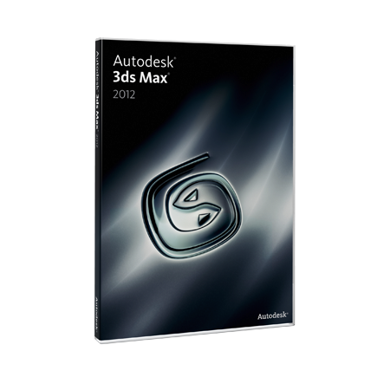
Adobe Photoshop CS5 will be used for any promotional material produced as well as texture maps for assets and characters.
Plasq Comic Life will be used to produce the comic strip storyboard cut scenes for in between the levels.
Vicon will be used as the software package to manage the Motion Capture animation files.
Home Designer Suite 8.0 has been used to model basic 3D versions of the level designs.
Programs from the Microsoft Office package will be used to produce the documentation for the project, with time plans created using Excel and documents written up using Word.
Procedures
The development process with be conducted in the following order:
- Concept Designs: ideas concepts, mood boards, level/character concepts.
- Asset Modelling: characters, assets, levels.
- Programming/Implementation: scripting and adding assets to the game engine.
- Testing: bug testing and play testing with feedback.
- Improvements: additional work on the final product due to developer testing and third party feedback.
- Presentation: unveiling of the product with promotional material.
This development process is essential to creating an end product that is playable, fun to play, bug free and well received by the target audience. The production will be managed with time plans and regular team meetings.
Game Engine
The game engine Unity Pro will be used to develop the game. This is due to a variety of reasons, mainly due to accessibility and ease of use. The Unity Pro engine can covert and build a game for all Android and iOS devices with minimal tweaking and relative ease. Another reason is the great abundance of learning materials available. These can be found in many forms both for free or for a minimal sum. Finally, the scripting interface within Unity Pro is vastly becoming an industry standard form that will be beneficial to learn for the development team. EZGui has been used to add features to the GUI menu within Unity Pro. ANBsoft’s owner has kindly allowed us use of this plugin due to the nature of our game, being a University project and not for commercial purposes.
Scripting Language
The game will be programmed using the Javascript language. This is due to the ease of use and abundance of learning materials available to assist both learning and development.
9.0 Concept Art
Game Characters
Jade Stone

Security Force

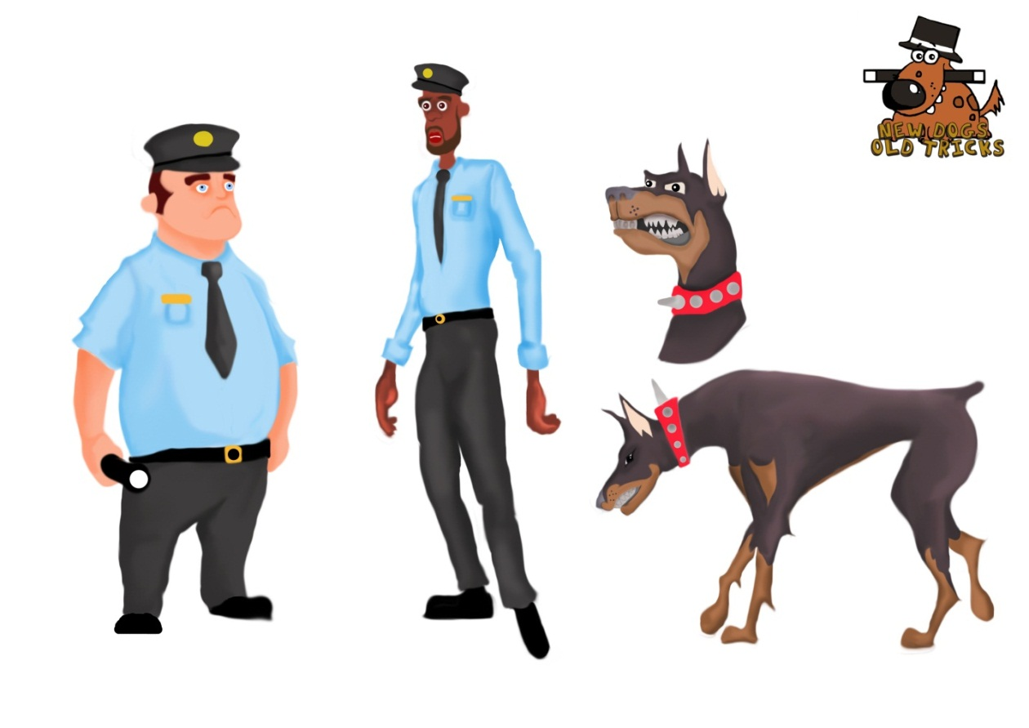
Levels
The hand drawn and digital versions for all the levels concepts can be seen in section 5.0 “Level Synopses”.
Cut Scenes
The game will feature a storyboard as a cut scene to explain the purpose of the story and fit the art style of the game. This will add extra depth to the levels and reasoning for the actions of the characters and locations within the game. The storyboard can be viewed in the appendix section.

10. 0 Project Management
Time Frame
The project is scheduled to be completed by 16/05/2012, with a time plan produced for each individual team member outlining their responsibilities and duties to the project implementation processes. The deadline is a strict date and cannot be moved, so several revisions of the time plan will be made to accommodate any changes to the game or alterations in time frames for certain elements of the production process. Production diaries for each team member will indicate further detail on the implementation methods for creating the game along with video logs showing the opinions and updates of each member of New Dogs Old Tricks. These two documentation elements will provide insight into the production team as a whole and as individuals, showing the development and growth of the game and overcoming problems during the development processes.
Bug Testing
When the assets have been created, levels built, music and audio effects included and scripting completed the game will be bug tested by all members of the team. A test plan is to be completed to ensure all bugs are removed before the game is play tested by external testers outside the production team, documenting how the game was tweaked and improved. The bug testing is essential to ensure the game flows as intended in the following areas:
- Character controls: walk, crouch walk and collecting loot/accessing buttons.
- Music and sound effects available at the correct points in the game.
- Menu buttons linking to the correct areas in both the GUI and pause menus.
- Collision detection within the levels, for example solid floor and walls, enemy surveillance fields of view losing a life for the player and exit areas linking to the correct follow on screen.
- Level select screen working correctly and all levels selectable at the correct times, with later levels only available after completing the previous level.
- Animations for characters relating to the desired affect i.e. crouch walk producing a different animation from the normal character walk and losing a life by coming into contact with a guard triggering the correct animation.
Player Testing & Feedback
Once the game runs fluidly with no errors, external play testers from the target audience will play through the levels and fill out feedback forms. The test plan will outline the game and provide them with a controls list. From here, the players must navigate the menus and complete the game levels commenting on the several criteria. The main areas of feedback will be:
- Level difficulty: whether the three stages are too similar, too high a difficulty or increase too rapidly in difficulty.
- Level length: whether the levels are too long to play on a phone format, and where and when the player would play the game on their phone.
- Level choice: whether the levels are too similar in style and if they include enough variety in enemies/aims.
- Character controls: how easy the character is to control and whether new functions could be added or positioned differently on the HUD screen.
- Visual appeal: whether the theme, style and colour scheme suit the game and format.
- Navigation: if the menus are clear and it is easy to move to where the player wants to move to i.e. Museum Level Hard Mode from opening the application.
The feedback will be used to alter any necessary features of the game before publication and improve the overall quality of the product. Both alpha and beta testing will be undertaken to ensure the game is of sufficient quality for the target audience.
Promotional Material
For the presentation of the final game, promotional material will be produced to present the game in a professional manner with advertising and publicity relating to the themes and style of the game. The promotional material to be created for the game will include:
- Posters
- App Store Logo
- Flyers
- Game Trailer/Developer Diary
- Advertising Banner
- Wallpapers
Downloadable Content
Jade’s Ransom has potential for future downloadable upgrades for additional content and monetisation schemes if initially successful.
Additional DLC Levels & Story Arcs
The game has scope for additional downloadable content, with further levels included set in between the Mansion and the Bank finale. Additional settings for these levels could include a technology store, casino and even Big Vince’s hideout, where the objective is to steal back her child rather than steal items.

Date Specific Event Updates
Date specific updates could be added to the application, which updates Easter Eggs into the game levels on specific dates. These could be linked into the achievements, for example having to find the entire calendar related Easter Eggs to receive the achievement icon. Ideas for these include guards wearing Santa hats in December, the Faberge egg turning into an Easter egg for Easter, the Museum banner changing to “Happy New Year!” and a bonus level on St. Patrick’s Day relating to leprechauns and pots of gold as initial ideas.
Characters
The inclusion of new characters within the game levels, such as Tommy Stone and Big Vince, to fit into new DLC levels content.
Monetisation
The game has potential for monetisation through DLC, with additional story arcs and level packs able to be added to the original free download for a minimal fee. Space on the screen could be modified for advertisements from external companies, while in-game company specific advertisements could be included for example a Coca Cola vending machine.
- Appendices
Image Bibliography
Metal Gear Solid 3 Screenshot [Online] Accessed on 05/02/2012, available at: http://gbatemp.net/topic/316323-metal-gear-solid-snake-eater-3d-has-fps-mode-and-crouch-walking/
Penelope Screenshot [Online] Accessed 05/02/2012, available at: http://droidmill.com/penelope-zeemote-ver-348279.html#.T7FuG-uDvms
Angry Bots Screenshot [Online] Accessed 05/02/2012, available at: http://taparena.com/2011/08/05/angry-bots-impressive-and-free-tech-demo-of-the-unity-engine/
Tomb Raider Render [Online] Accessed 05/02/2012, available at: http://tomb-raider-anniversary.com/tomb-raider-anniversary-game/about/
Thief Screenshot [Online] Accessed 05/02/2012, available at: http://www.fragland.net/news/New-Thief-game-in-the-making/18894/
Perfect Dark Render [Online] Accessed 05/02/2012, available at: http://www.grantkirkhope.com/perfectdark.html
Pixar Render [Online] Accessed 05/02/2012, available at: http://pixar.wikia.com/File:Pixar-Characters.jpg
Android Logo [Online] Accessed 23/02/2012, available at: http://blog.secfence.com/2011/08/android-spyware-found-in-the-wild-as-a-google-app/android-logo/
iPhone 5 Logo [Online] Accessed 23/02/2012, available at: http://www.besttechinfo.com/apple-cuts-iphone-4-production-iphone-5-launch/
iPad Logo [Online] Accessed 23/02/2012, available at: http://logosociety.blogspot.co.uk/2011/09/apple-ipad-logo.html
Unity Pro Logo [Online] Accessed 23/02/2012, available at: http://www.gamesta.com/aspiring-devs-unity-ios-and-android-free-until-april-8/unity-logo/
ZBrush 4 Logo [Online] Accessed 23/03/2012, available at: http://www.3dworldmag.com/2011/02/25/win-a-copy-of-zbrush-4-with-the-3d-world-creative-challenge/
3D Studio Max 2012 Box Cover [Online] Accessed 23/02/2012, available at: http://down.cd/6683/buy-Autodesk-3ds-Max-2012-x32-x64-download/
Adobe Photoshop CS5 Logo [Online] Accessed on 23/02/2012, available at: http://en.wikipedia.org/wiki/File:Photoshop_logo.svg
Comic Life Logo [Online] Accessed on 23/02/2012, available at: http://plasq.com/press/2009/06/plasq-releases-comic-life-1.5-for-mac
Vicon Logo [Online] Accessed on 23/02/2012, available at: http://www.health.utah.edu/pt/research/mocap/index.html
Home Designer Suite 8.0 Box Cover [Online] Accessed on 23/02/2012, available at: http://store.hermanstreet.com/index.php?p=np&page_id=home-designer-suite-2012-download&ICID=pin-home%20designer%20suite%202012-03-19hds-ad-sky
Microsoft Office Logo [Online] Accessed 23/02/2012, available at: http://www.hitechreview.com/it-products/tablets/microsoft-to-release-office-for-apple-ipad/34626/
Final Character Renders
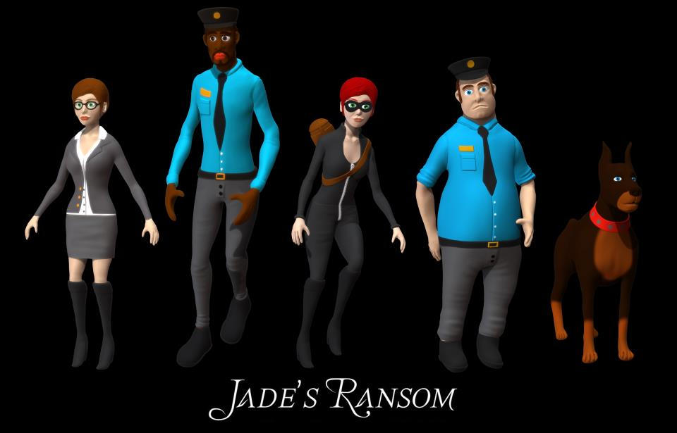
Comic
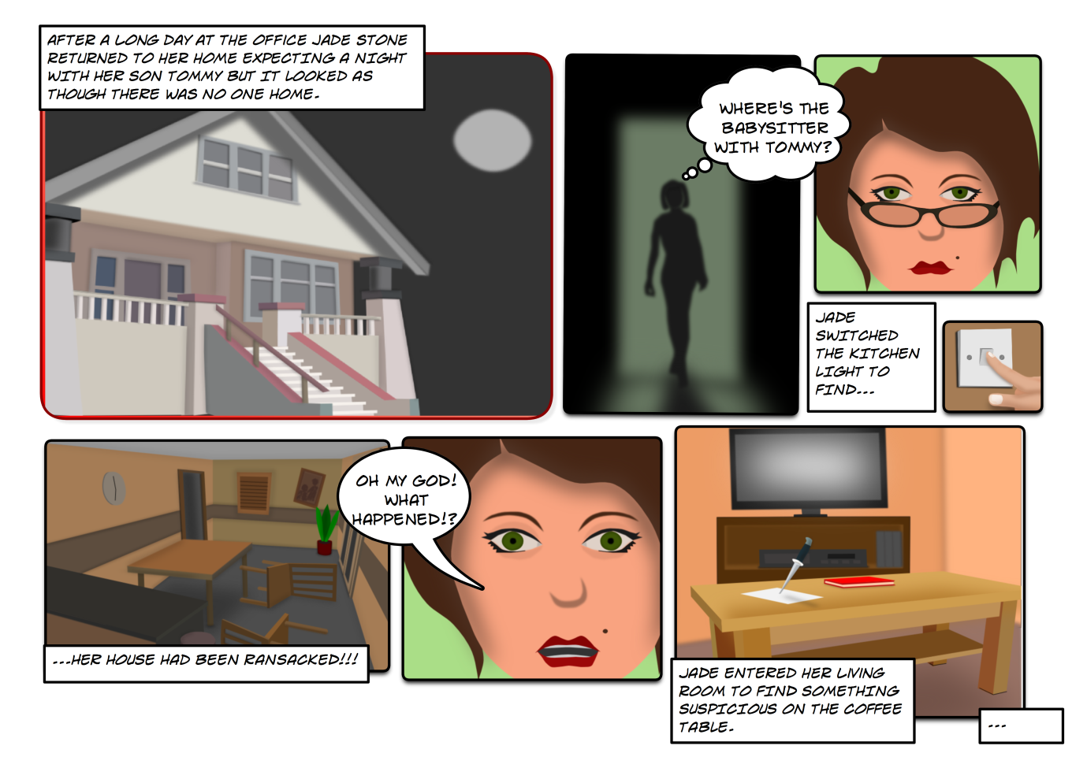
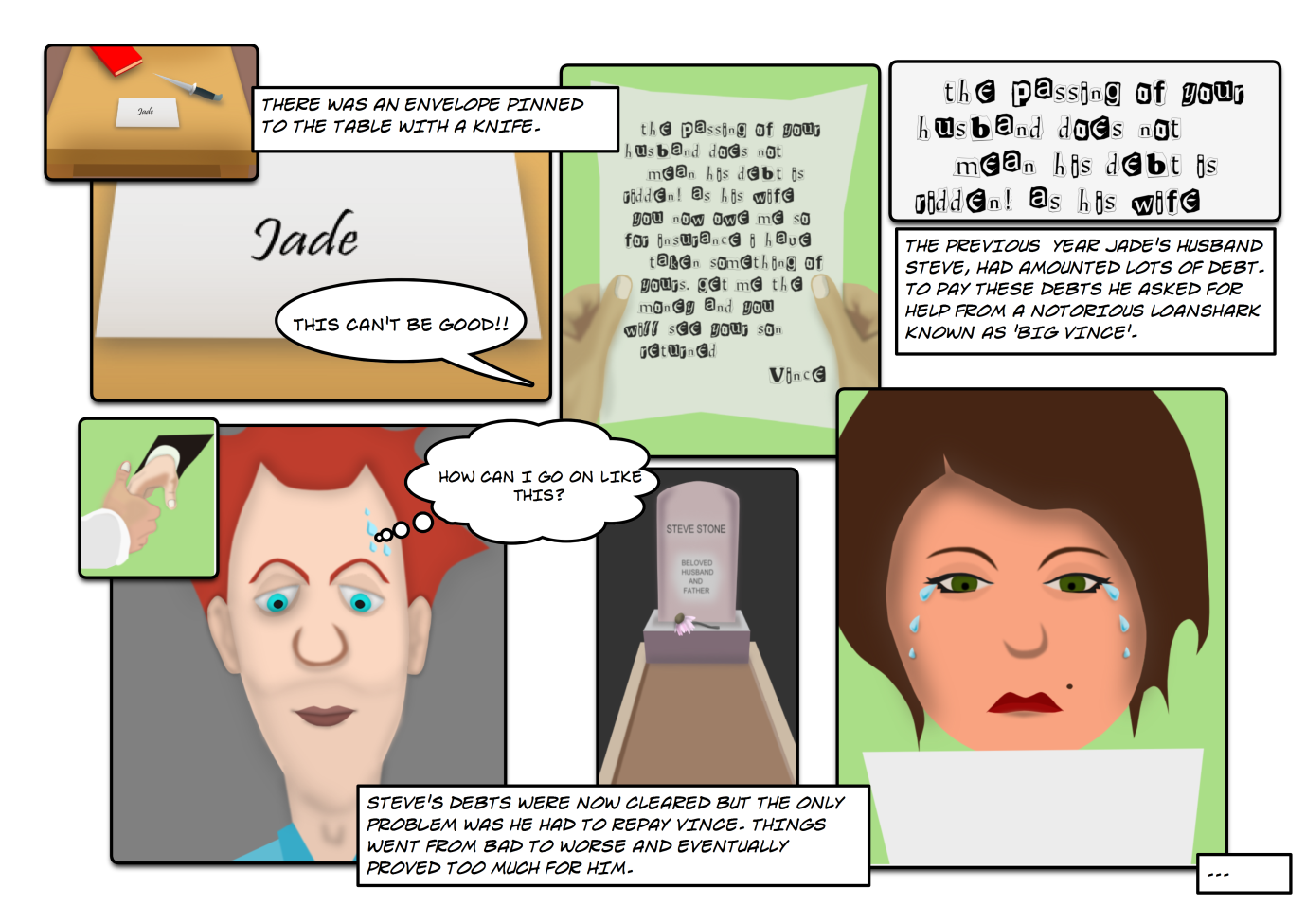

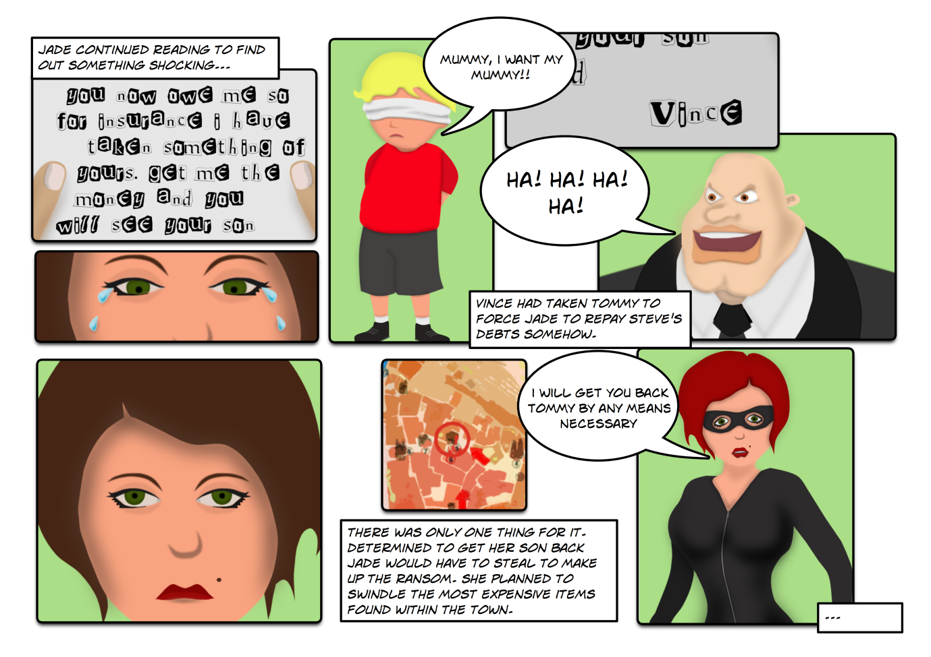
Achievements
